GitHub Actions → Automatic Rollback -> slack notification
https://github.com/letslearn207/action/tree/main/.github/workflows
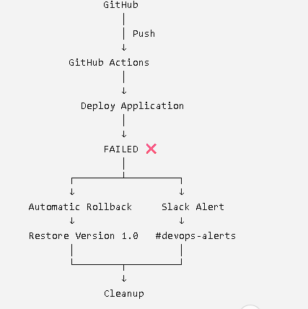
PART 1 — Create the GitHub Repository
Go to GitHub and create a new repository.
Repository name:
github-actions-self-healing
You can make it Public for this lab.
After creating it, you should have:
github-actions-self-healing
Nothing else is required yet.
PART 2 — Create the Workflow Folder
Inside the repository:
Add file → Create new file
Filename:
.github/workflows/self-healing.yml
So your repository will eventually look like:
github-actions-self-healing
│
└── .github
└── workflows
└── self-healing.yml
PART 3 — First Create a Simple Deployment Workflow
For now, put this code in self-healing.yml:
name: Self Healing Deployment
on:
push:
jobs:
deployment:
runs-on: ubuntu-latest
steps:
- name: Deploy Application
run: |
echo "Starting deployment..."
echo "Deploying version 2.0..."
echo "Deployment failed!"
exit 1

###
PART 4 — Run the Workflow
Go to:
GitHub → Actions
You should see:
Self Healing Deployment
Click it.
You should see:
Deploy Application
❌
And the log:
Starting deployment...
Deploying version 2.0...
Deployment failed!

Error: Process completed with exit code 1.
Why did it fail?
Because we intentionally wrote:
exit 1
exit 1 means:
The command failed.
We are doing this deliberately so we can demonstrate error handling.
PART 5 — Add Automatic Rollback
Now replace your workflow with:
name: Self Healing Deployment
on:
push:
jobs:
deployment:
runs-on: ubuntu-latest
steps:
- name: Deploy Application
id: deployment
run: |
echo "Starting deployment..."
echo "Deploying version 2.0..."
echo "Deployment failed!"
exit 1
- name: Automatic Rollback
if: failure()
run: |
echo "Deployment failed!"
echo "Starting automatic rollback..."
echo "Restoring version 1.0..."
echo "Rollback completed successfully!"

PART 6 — Understand failure()
This is the important line:
if: failure()
It means:
Run this step when a previous step has failed.
So:
Deploy Application
↓
❌
↓
if: failure()
↓
Automatic Rollback
↓
✅
PART 7 — Test Rollback
Go to:
Actions → Self Healing Deployment
You should now see:
Set up job ✅

Deploy Application ❌

Automatic Rollback ✅

Complete job ✅
And rollback should print:
Deployment failed!

Starting automatic rollback...

Restoring version 1.0...

Rollback completed successfully!
At this point you have completed the Automatic Rollback portion.

PART 8 — Now Connect Slack
Now we make the alert real.
We need:
Slack
↓
Incoming Webhook
↓
GitHub Secret
↓
GitHub Actions
Slack's official GitHub Actions documentation uses an incoming webhook URL stored as a GitHub repository secret called SLACK_WEBHOOK_URL.
PART 9 — Create a Slack Channel
Open Slack.
Create a channel:
#devops-alerts
You can use any name you want.
For this lab, use:
#devops-alerts

PART 10 — Create the Slack App
Go to the official Slack API page: https://api.slack.com/apps
Click:
Create New App
Select:
From scratch
App name:
GitHub Actions Alert
Select your Slack workspace.
Create the app.
Setting
Income webhook -> generate webhook
##
Add the Webhook to Your Slack Channel
Click:
Add New Webhook to Workspace
Select:
#devops-alerts
Click:
Allow
Slack will generate a URL similar to:
https://hooks.slack.com/services/XXXXXXXX/XXXXXXXX/XXXXXXXX
Create the GitHub Secret
Go back to your GitHub repository:
github-actions-self-healing
Go to:
Settings
↓
Secrets and variables
↓
Actions
Click:
New repository secret
Name:
SLACK_WEBHOOK_URL
Value:
https://hooks.slack.com/services/XXXXXXXX/XXXXXXXX/XXXXXXXX
Click:
Add secret
GitHub stores secrets securely and automatically masks secret values in workflow logs
##
Add Slack to the Workflow
Now edit:
.github/workflows/self-healing.yml
name: Self Healing Deployment
on:
push:
jobs:
deployment:
runs-on: ubuntu-latest
steps:
# STEP 1
- name: Deploy Application
id: deployment
run: |
echo "Starting deployment..."
echo "Deploying version 2.0..."
echo "Deployment failed!"
exit 1
# STEP 2
- name: Automatic Rollback
if: failure()
run: |
echo "Deployment failed!"
echo "Starting automatic rollback..."
echo "Restoring version 1.0..."
echo "Rollback completed successfully!"
# STEP 3
- name: Send Slack Alert
if: failure()
uses: slackapi/slack-github-action@v4
with:
webhook: ${{ secrets.SLACK_WEBHOOK_URL }}
webhook-type: incoming-webhook
errors: true
retries: 0
payload: |
text: "🚨 Deployment failed in GitHub Actions!"

#########

